**Test Driven Development (TDD)** is software development approach in which test cases are developed to specify and validate what the code will do. In simple terms, test cases for each functionality are created and tested first and if the test fails then the new code is written in order to pass the test and making code simple and bug-free.

Test-Driven Development starts with designing and developing tests for every small functionality of an application. TDD framework instructs developers to write new code only if an automated test has failed. This avoids duplication of code. The TDD full form is Test-driven development.

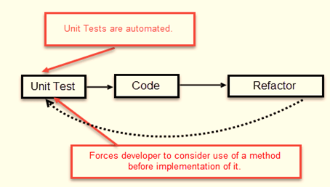

The simple concept of TDD is to write and correct the failed tests before writing new code (before development). This helps to avoid duplication of code as we write a small amount of code at a time in order to pass tests. (Tests are nothing but requirement conditions that we need to test to fulfill them).

Test-Driven development is a process of developing and running automated test before actual development of the application. Hence, TDD sometimes also called as **Test First Development.**

**How to perform TDD Test**

Following steps define how to perform TDD test,

1. Add a test.
2. Run all tests and see if any new test fails.
3. Write some code.
4. Run tests and Refactor code.
5. Repeat.

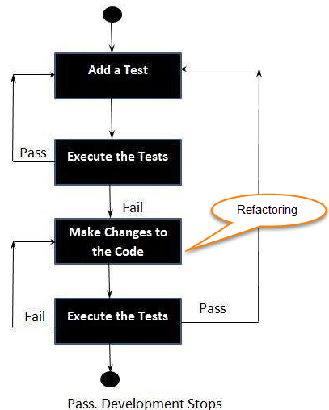

Five Steps of Test-Driven Development

**TDD cycle defines**

1. Write a test
2. Make it run.
3. Change the code to make it right i.e. Refactor.
4. Repeat process.

**Some clarifications about TDD:**

* TDD approach is neither about “Testing” nor about “Design”.
* TDD does not mean “write some of the tests, then build a system that passes the tests.
* TDD does not mean “do lots of Testing.”